**SCHOOL OF COMPUTING AND MATHEMATICS**

**ITC515 – Professional Programming Practise**

**Assignment 4**

ID: 11581032

Name: Vu Quach

**Lecturer: Dr Recept Ulusoy**

Contents

1. How to debug a program using Eclipse and Debugger. 3

2. Bugs found 5

3. Bugs fixed 5

# URL repository:

Master origin: <https://github.com/zagv/crown_and_anchor.git>

My branch: <https://github.com/zagv/crown_and_anchor/tree/vuq>

# How to debug a program using Eclipse and Debugger.

1. First toggle the break point where we want the program is stop to debug

2. Then go to the menu Run-->Debug As--> Java Application.

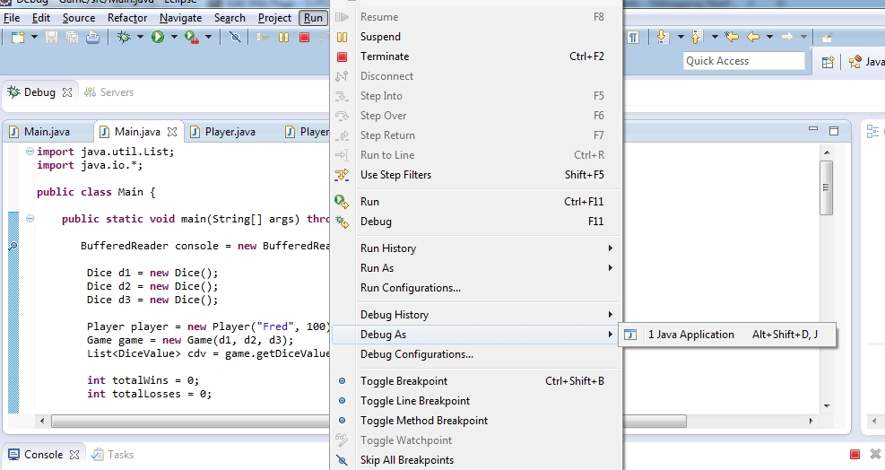c

The perspective after running is as follow:

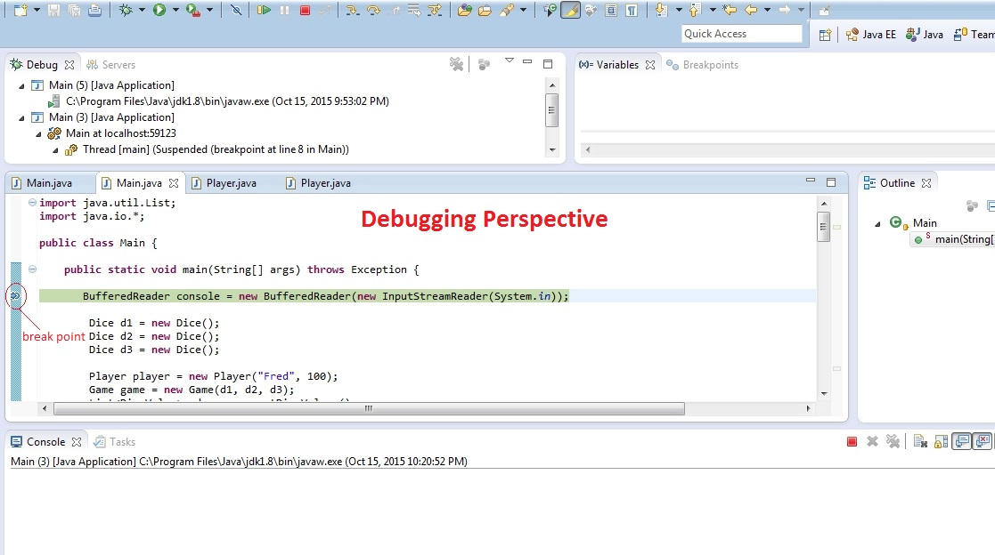

More details explain how to use Eclipse Debugger.

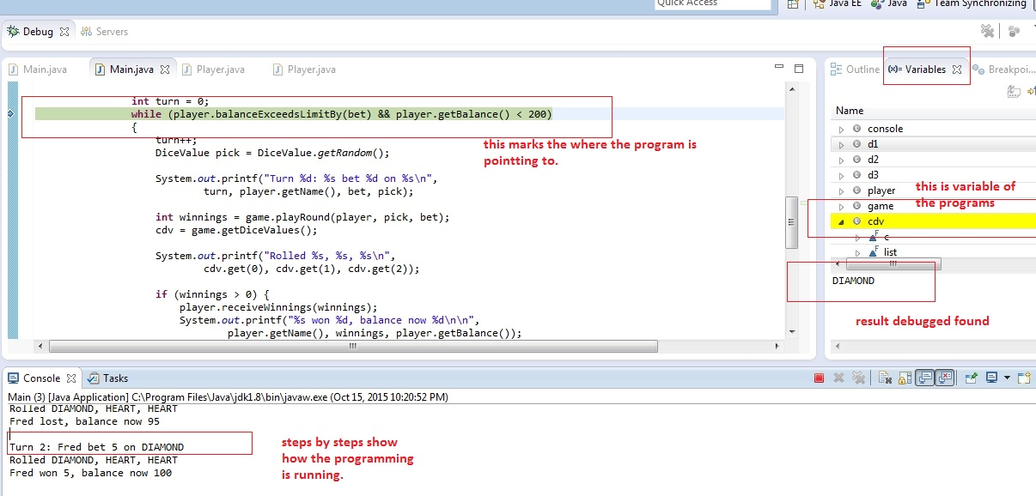

# Bugs found

## Player can only bet $5 each turn as show in the figure below:

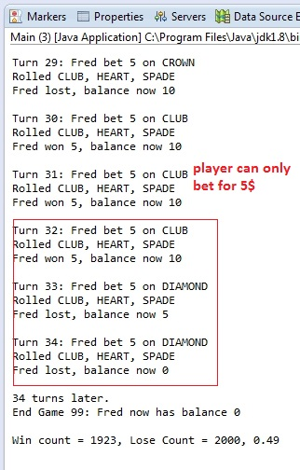

## Player won $10 but the balance just increase $5:

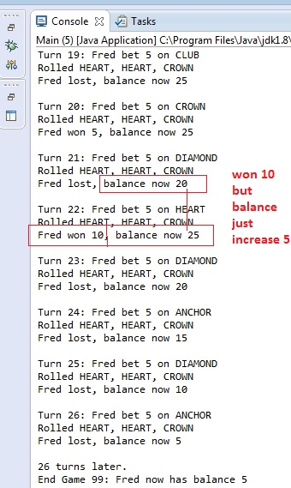

## The Game end without reaching the balance limit

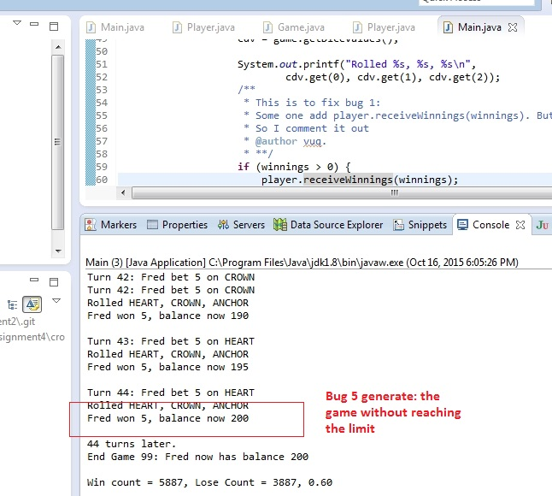

## The Game end without reaching the balance limit. It should $0 instead of $5

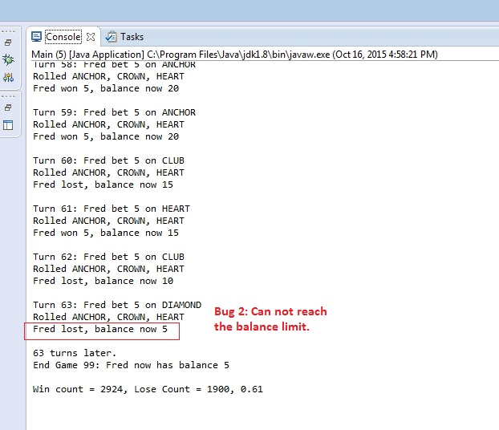

# Bugs fixed

## Player can now bet with SPADE

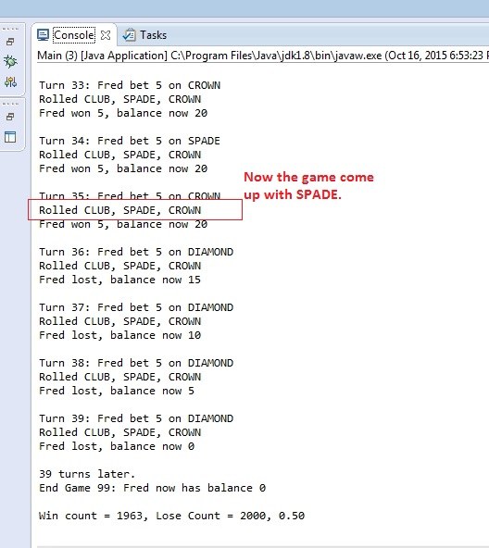

## The Game can reach the limit now ($0)

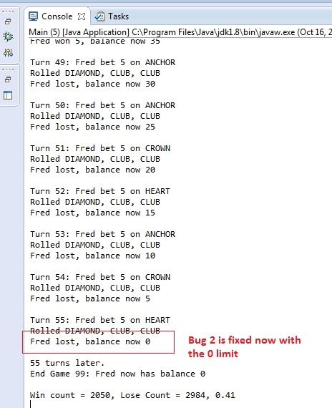

## Fix the bug can not set amount of bet for players:

